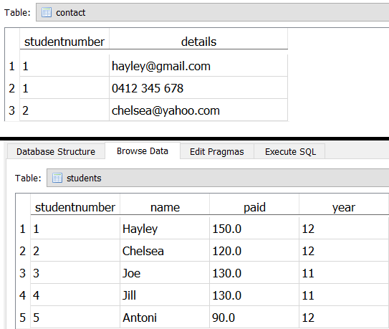
- Show all of the fields in the students table for student named Hayley
- Show the total amount paid for only Joe and Jill
- Show all the fields for students in year 11, or students in year 12 who have paid less than $100
- Show only the students that have any contact details records
- Show all the students, as well as the students who have contact details recorded
- Show the amount paid and year level for any student with a “yahoo.com” email address
- How much has been paid in total
- What is the minimum amount that has been paid
- The total cost of the formal is $150. Show a list of student names and how much each student still owes.
- Count the number of students who have paid more than $100
- Count the number of students (grouped by each grade) who have paid more than $100
- Work out the average amount that all students in each grade have paid.
- Work out the average amount that all students in each grade have paid, but exclude grades that have an average amount less than $125
- Show all the fields for students in year 11, or students in year 12 who have paid more than $100. Order the result by amount paid DESC, then student name ASC
- Show the COUNT of a list of DISTINCT amounts paid
- Antoni handed in $35 more than what he has currently paid. Show a list of students that have still paid more than Antoni. Use a correlated subquery.
- Show only the COUNT of students in each year level. ALIAS the single column as “n”
- For “n” in query #17 (previous question), LIMIT this to the highest number in the column
- Get the same result from query #18 but this time use a correlated subquery. (HARD)
- How much less has year 11 paid in total than year 12. (THIS QUERY IS TOO HARD)

SELECT COUNT(year) AS "n"
FROM students
GROUP BY year
ORDER by n DESC
LIMIT 1
SELECT MIN(n)
FROM (
SELECT COUNT(year) AS "n"
FROM students
GROUP BY year
)
SELECT x - y
FROM (
(SELECT SUM(paid) AS "x"
FROM students
WHERE year == 11)
JOIN
(SELECT SUM(paid) AS "y"
FROM students
WHERE year == 12)
)

